Files

Code5-2_flex.css

Code5-2.html

Instructions

Code5-2_flex

@charset "utf-8";

/*

   New Perspectives on HTML5 and CSS3, 8th Edition

   Tutorial 5

   Coding Challenge 2

   Author:

   Date: 04/21/2023

   Filename: code5-2_flex.css

*/

section {

  display: flex;

  flex-wrap: wrap-reverse;

  flex-flow: row wrap-reverse;

}

div.card {

  display: flex;

  flex: 1 1 200px;

  flex-direction: column;

  flex-wrap: nowrap;

  justify-content: space-between;

  align-items: center;

}

Code5-2.html

<!doctype html>

<html lang="en">

<head>

   <!--

   New Perspectives on HTML5 and CSS3, 8th Edition

   Tutorial 5

   Coding Challenge 2

   Author:

   Date: 04/21/2023

   Filename: code5-2.html

   -->

   <meta charset="utf-8">

   <title>Coding Challenge 5-2</title>

   <link href="code5-2_layout.css" rel="stylesheet" />

   <link href="code5-2_flex.css" rel="stylesheet" />

</head>

<body>

   <h1>Social Media Sites</h1>

   <section>

      <div class="card">

         <header><h1>Facebook</h1></header>

         <img src="facebook.png" alt="Facebook" class="icon" />

         <footer>238,150 followers</footer>

      </div>

      <div class="card">

         <header><h1>Twitter</h1></header>

         <img src="twitter.png" alt="Twitter" class="icon" />

         <footer>48,871 followers</footer>

      </div>

      <div class="card">

         <header><h1>Instagram</h1></header>

         <img src="instagram.png" alt="Instagram" class="icon" />

         <footer>171,244 followers</footer>

      </div>

      <div class="card">

         <header><h1>GooglePlus</h1></header>

         <img src="google-plus.png" alt="GooglePlus" class="icon" />

         <footer>64,288 followers</footer>

      </div>

      <div class="card">

         <header><h1>YouTube</h1></header>

         <img src="youtube.png" alt="YouTube" class="icon" />

         <footer>Subscribe to our Channel</footer>

      </div>

      <div class="card">

         <header><h1>Vimeo</h1></header>

         <img src="vimeo.png" alt="Vimeo" class="icon" />

         <footer>Get the Vimeo Feed</footer>

      </div>

      <div class="card">

         <header><h1>Skype</h1></header>

         <img src="share.png" alt="Skype" class="icon" />

         <footer>Join a Skype Chat</footer>

      </div>

      <div class="card">

         <header><h1>Pinterest</h1></header>

         <img src="pinterest.png" alt="Pinterest" class="icon" />

         <footer>Create your Page</footer>

      </div>

      <div class="card">

         <header><h1>Bloggr</h1></header>

         <img src="bloggr.png" alt="Bloggr" class="icon" />

         <footer>Subscribe to our Feed</footer>

      </div>

      <div class="card">

         <header><h1>Tumblr</h1></header>

         <img src="tumblr.png" alt="Tumblr" class="icon" />

         <footer>Get Daily Updates</footer>

      </div>

      <div class="card">

         <header><h1>Share</h1></header>

         <img src="share.png" alt="Share" class="icon" />

         <footer>Share our Content</footer>

      </div>

      <div class="card">

         <header><h1>E-mail</h1></header>

         <img src="email.png" alt="email" class="icon" />

         <footer>E-mail Us!</footer>

      </div>

   </section>

</body>

</html>

Instructions

*Figure 5–58* shows the layout of a page that displays cards containing social media icons. Create this page using CSS flex styles so that the icons are always laid out in rows and columns for any screen width.

[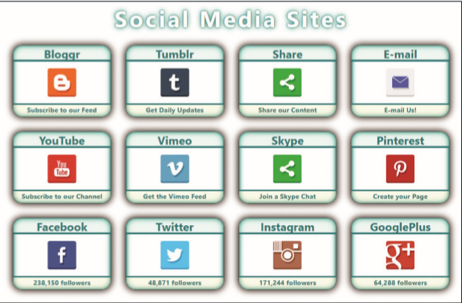](https://cdn.filestackcontent.com/JGL2SklQdUg2Hq8F3g8w)*Figure 5-58*

Do the following:

Open the file code5-2.html andcode5-2_flex.css and in the comment section enter your **name** (First + Last) and the **date** (MM/DD/YYYY) into the Author: and Date: fields of each file.

Go to the code5-2.html file and within the head section insert link elements linking the page to the code5-2_layout.css and code5-2_flex.css files. Review the contents of each file.

Open the code5-2_flex.css file. Display the section element as a flexbox. Set the flow of items within the flexbox to go in row order with reverse wrapping so that the first item (Facebook) appears in the bottom-left corner and the last item (E-mail) appears in the top-right corner.

Complete this task in conjunction with the following task: "Apply flex layout styles to card class's div elements".

Set the growth and shrink rate of the div elements of the card class to **1** and **1**. Set the flex basis of those elements to **200** pixels. Display each div element of the card class itself as a flexbox.

Next, apply the following flex layout to the items within the card div elements:

1. Lay out the items in column order with no wrapping.
2. Justify the content of the items within the flexbox with space between.
3. Center each of the items with respect to the cross axis.

Complete this task in conjunction with the previous task: "Style the section element as a flexbox".

Open the code5-2.html file in the browser preview. Test the layout under different screen widths, verifying that the div cards always fill up the page grid and that for a width small enough, the contents are laid out in a single column.